St THERESA PRIMARY SCHOOL

TERM 1

AGRICULTURE 5

NAME: ______________________ SURNAME: ________________________________

SECTION A
50 Marks
Answer all the questions in the space provided.
- What is Agriculture?(1.1.1.1)
________________________________________________________________________________________________________________________________________________________________________________________________________________________

- Give three(3) reasons why Agriculture is important to Batswana.(1.1.1.4)
- _______________________________________________
- _______________________________________________
- _______________________________________________

- State two branches of Agriculture (1.1.1.2)
- ______________________________________________
- ______________________________________________
- Agriculture in Botswana has many problems affecting productivity.

- Name any two problems that famers encounter (1.1.1.6)
_______________________________________________________________________________________________________________________________________________________________________________________________________________

- Give solutions to the problems mentioned above (1.1.1.7)
_______________________________________________________________________________________________________________________________________________________________________________________________________________

- Agriculture is related to other courses in Botswana. Name any two careers that one can do from agriculture.(1.1.1.9)
________________________________________________________________________________________________________________________________________________________________________________________________________________________

Use the information below to answer question 6.

Mr. lion grows maize and beans in his field. He sells his harvest to the local
Shops and individuals so that he can support his wife and two children.

- Which system of farming is practiced by Mr. Lion? (1.1.1.3)
________________________________________

- At what level of production is Mr. Lion practicing his farming?
________________________________________

- Name any two government programmes that can help Mr. Lion improve his business.
____________________________________________________________________________________________________________________________________

7. Which branch of agriculture deals with management of field crops? (1.1.1.2)
________________________________________________________________________
8. What is the difference between pastoral farming and arable farming? (1.1.1.3)
_________________________________________________________________________________________________________________________________________________________________________________________________________________________________
9. Differentiate between farm implements and farm tools. (1.2.1.1)
____________________________________________________________________________________________________________________________________________________________________________________________________________________
10. Explain the following types of Agriculture (1.1.1.3)
- . commercial farming:
____________________________________________________________________________________________________________________________________________________________

- Subsistence farming:
________________________________________________________________________________________________________________________________________________

- State two problems caused by farm implements.(1.3.1.5)
- ____________________________________________________________________________________________________________________________________
- ____________________________________________________________________________________________________________________________________

- Suggest solutions to the problems above. (1.3.1.6)
- ____________________________________________________________________________________________________________________________________
- ____________________________________________________________________________________________________________________________________

- Give two farm tools that are used for digging (1.2.1.3)
- ______________________________________
- ______________________________________
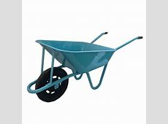
14. Use the picture above to answer question 14
- What is the name of the farm tool shown above? _____________________________

- What is the use of the farm tool mentioned above?
_____________________________________________________________________________________________________________________________________________________________________________________________________________________________________________

15. Give two (2) any impact of HIV and Aids to agricultural productivity in Botswana (1.1.1.5).
________________________________________________________________________________________________________________________________________________________________________________________________________________________________________________________________________________________________

16. What is meant by biotechnology? (1.4.1.1)
_____________________________________________________________________________________________________________________________________________________________________________________________________________________________________________

17. Give two products of traditional biotechnology (1.4.1.3)
- ___________________________________________________
- ___________________________________________________

18. Name following implement and tools.

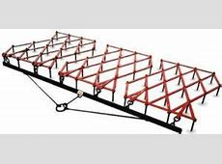name____________________________________
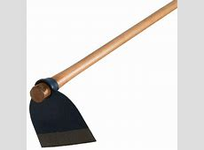name________________________________

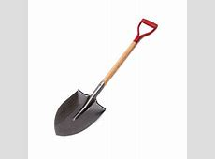name_____________________________________

19. Give three ways in which the farmer can take care of the above tools and implements.
- ______________________________________________________________________________________________________________________________________________
- ______________________________________________________________________________________________________________________________________________
- ______________________________________________________________________________________________________________________________________________
20. State the type of biotechnology which is used to turn fresh milk into sour milk (madila) (1.4.1.3)
- _____________________________________________

21.(a) Which government organization helps dairy farmers to improve dairy productivity?
- _____________________________________

(b) What does the following government programmes stands for?

- CEDA:________________________________________________________________
- LEA:___________________________________________________________________
- NAMPAAD:____________________________________________________________________________________________________________________________________
Use the diagrams below to answer question 22

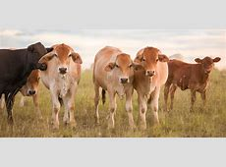

- Which system of agriculture is shown by the above diagram/picture.(1.1.1.3
__________________________________________

- Describe the above system 22 (i). (1.1.1.3)
________________________________________________________________________________________________________________________________________________
- Which branch of agriculture helps farmers when animals are sick?
_____________________________________________________

******GOOD LUCK******

